**Steps to download volume id’s into data capsule**

Step-1- go to htrc solr website and download the selected volumes from the volume IDs on the left hand side.

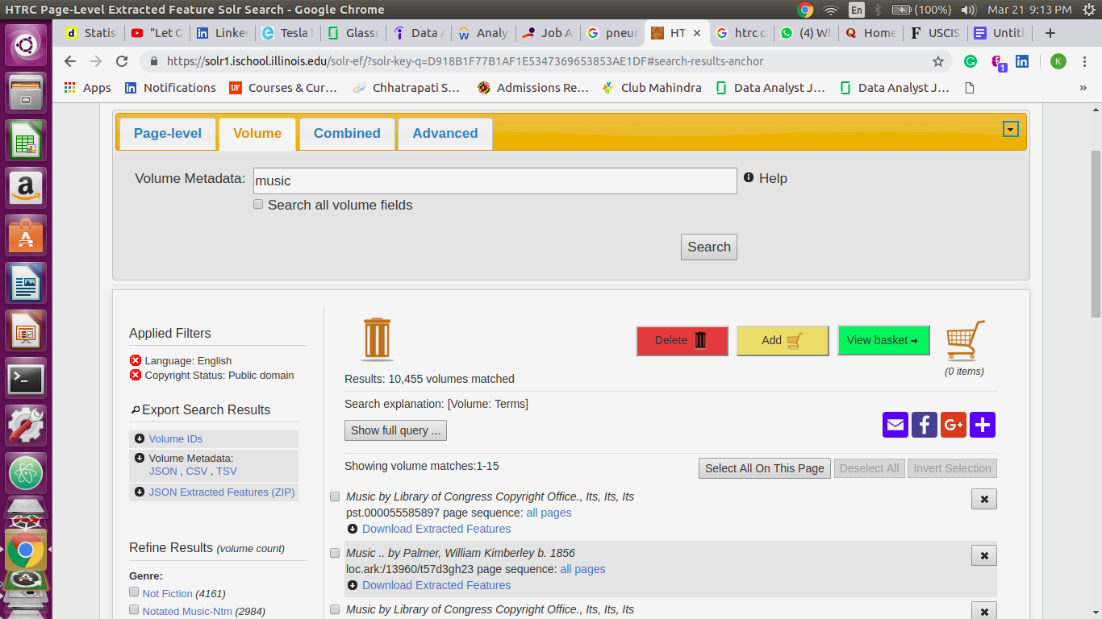

Step 2 upload the data extraction code and volume IDs downloaded from step 1 in the single git hub repository and name that repository as HTRC

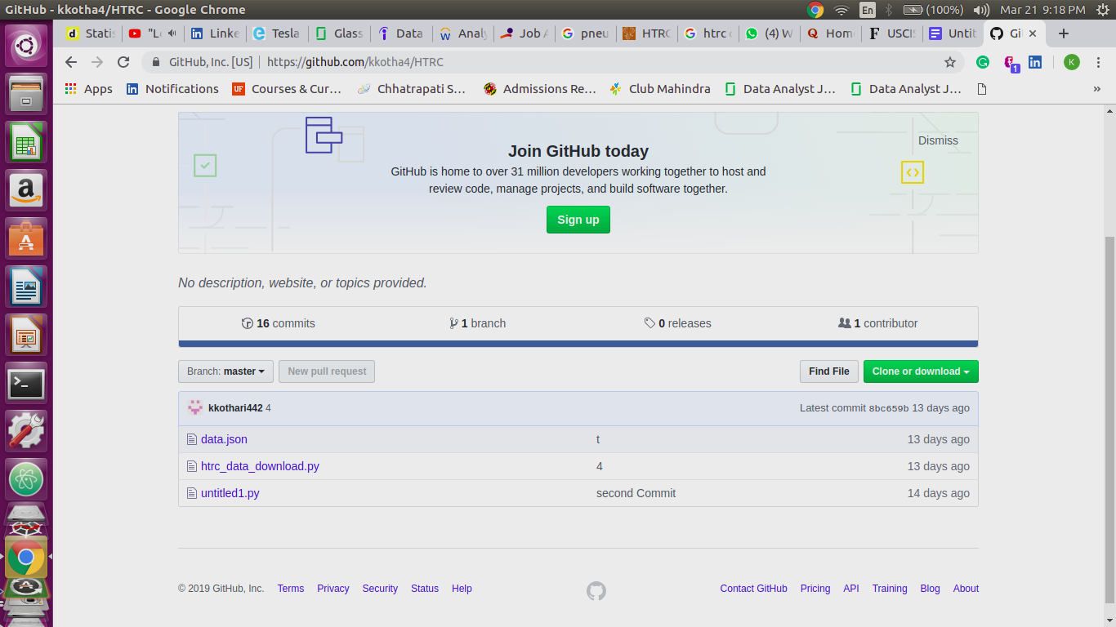

Step 3 create a directory in the data capsule using the below command

**mkdir download_htrc**

Step 4 clone your github repository given by the url on the right hand side in the git hub page into the local repository created in step 3 using following command

**1-cd download_htrc**

**2-git clone “your github repository url”**

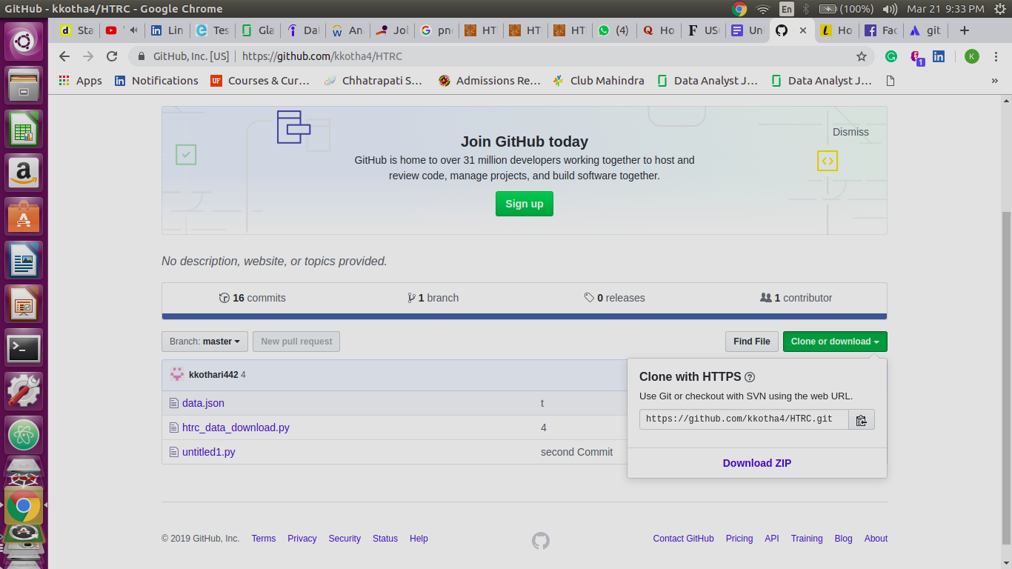

Step 5

Run the python download script inside the htrc folder in data capsule in the secure mode

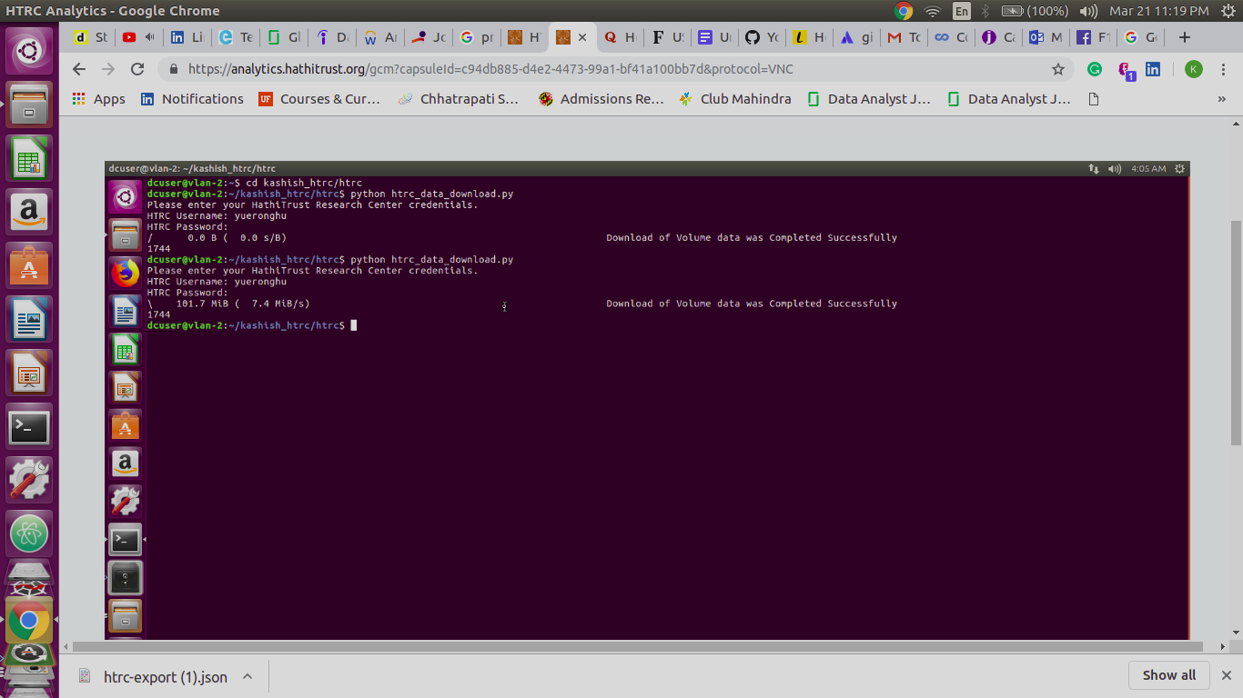

Step 6 Your result can be seen in htrc directory under **downloaded_volumes folder**:

